American Liberalism and the Imperial Temptation

Dan Nexon (with Paul Musgrave)

The first decade of the twenty-first century marked a new iteration of debate about “American Empire.” The September 11, 2001, terrorist attacks on the United States, the U.S.-led invasion of Afghanistan, the promulgation of the so-called Bush Doctrine, and the debate preceding the invasion of Iraq drove interest in the idea that the United States was, or was becoming, an imperial power. The proposition was not new: critics of American foreign policy had long criticized its putatively imperialist nature. But this time many defenders of the U.S. role in the world embraced the notion of American Empire.

Numerous scholars and commentators seized the notion and ran with it. The debate transformed Niall Ferguson, a Scottish historian dedicated to rehabilitating the image of the British Empire, into a major public intellectual in the United States. Michael Ignatieff published two well-read articles in the New York Times Magazine about the lessons of empire for the United States. Ivo Daalder and James Lindsay argued in the New York Times that the United States has been an empire since it acquired the Philippines after the Spanish-American War in 1898. The choice, they maintained, was not “if” the United States had an empire but over “what kind” of empire it would have: whether it would be a multilateral empire of consent or a unilateral one of coercion.

Others argued for more precise understandings of “empire” and its relationship to the United States. G. John Ikenberry warned against the “imperial temptation” generated by the War on Terror, and specifically criticized the Bush administration’s foreign policy for its neo-imperialist character. In contrast to Daalder and Lindsay, Ikenberry argued that liberal-internationalist multilateralism is as an alternative to empire. After the Second World War, the United States built an international order composed largely of multilateral institutions. This order signaled precisely that the U.S. would not exploit its dominant position to engage in empire-building . The choice, then, was whether Washington would consolidate a rule-based order along liberal internationalist lines or to pursue a self-defeating imperial agenda. As he argued, advocates of Bush foreign policy:

Call for American unilateral and pre-emptive, even preventive, use of force, facilitated if possible by coalitions of the willing—but ultimately unconstrained by the rules and norms of the international community. At the extreme, these notions form a neo-imperial vision in which the United States arrogates to itself a global role of setting standards, determining threats, using force, and meting out justice. It is a vision in which sovereign becomes more absolute for America even as it becomes conditional for countries that challenge Washington’s standards of internal and external behavior .

Ten years on, two important issues remain to be settled in the “American Empire” debate:

- What is the relationship between liberal foreign policy and empire? Does liberalism account for the American “imperial temptation,” as some argue, or are liberal internationalism and American Empire alternatives to one another?

- What specifically renders the Bush Doctrine imperial? Despite the many caricatures of George W. Bush as a Roman emperor, there’s nothing obvious about the connection between unilateralism and empire. Unilateralism, especially in defense of national security, is a prerogative of sovereignty.

Answering both these questions requires a defensible conception of empire. Those who want to claim that the U.S. is certainly, definitely, ineffably an empire base their claims on what we might charitably call “loose” definitions of the term. “Empire” too often becomes a synonym for any state that possesses a large territory, a big military, force-projection capability, and lots of influence. For their part, many of those who deny that the U.S. is an empire also stack the deck by introducing irrelevant criteria. Examples of both forms of hyperbole come from Bush administration insiders. Journalist Ron Suskind recorded one senior Bush aide in 2004 as crowing that “We’re an empire now, and when we act, we create our own reality. And while you’re studying that reality—judiciously, as you will—we’ll act again, creating other new realities, which you can study too, and that's how things will sort out. We’re history’s actors . . . and you, all of you, will be left to just study what we do.” By contrast, Vice President Richard Cheney declared, “[I]f we were an empire, we would currently preside over a much greater piece of the Earth’s surface than we do. That’s not the way we operate.”
In this chapter, we put forth a better definition of empire. We offer an ideal-typical account of the structure of empires that allows us to spot the existence of imperial relations in international and domestic politics. This approach makes clear which aspects of international liberalism generate an impulse toward empire and which mitigate it. Neoconservatism creates an imperial temptation not because of its putatively illiberal characteristics but because of its emphasis on expanding the zone of democratic governance at the domestic level. To the extent that states pursue the aggressive democratization of other states, they inevitably form informal imperial relations with other states. Given that the core of imperial relations is a hierarchical relationship between the core and the periphery, the imposition of a new form of rule, even one that is quintessentially liberal, is inescapably imperial. By contrast, liberal internationalism of the type endorsed by Ikenberry emphasizes liberal global governance, which militates against the formation of informal empires among states. However, rather than replacing informal empire altogether, liberal internationalism displaces imperial relationships and functions into the hands of international organizations and multilateral coalitions.

How (Not) to Think About Empire

What are empires? Empires are a specific kind of political community—one organized along different principles from nation-states, city-leagues, and any number of other ways that human beings have exercised authority over one another. Empires are rimless hub-and-spoke systems in which lines of authority run from an imperial core (or metropole) to distinctive peripheries (or segments), but not among peripheries themselves (see Figure 1). The core’s position as the crucial broker between peripheries provides it with important political advantages over each individual imperial province, including its ability to direct the allocation of resources in the imperial system. Critically, empires are both hierarchical (in that the core is superordinate to peripheral actors) and based upon distinct bargains (heterogenous contracting) between the core and each segment of the periphery.
The rimless hub-and-spoke character of empires has much to do with the way that empires combine indirect rule with heterogeneous contracting. In empires, central authorities—the emperor and other imperial officials residing in the core (whatever their title may be)—rule indirectly via local intermediaries who enjoy significant latitude over many areas of rulemaking and enforcement. Whether called “governors,” “proconsuls,” “viceroys,” or “satraps,” these intermediaries may hail from the core, from other provinces, or from the periphery in which they exercise authority. Some, such as in so-called “indirect rule” systems, may be indigenous rulers incorporated into the imperial system—such as the Princes of Muscovy under the Golden Horde—while others may be imperial bureaucrats appointed to run a periphery on behalf of the empire .

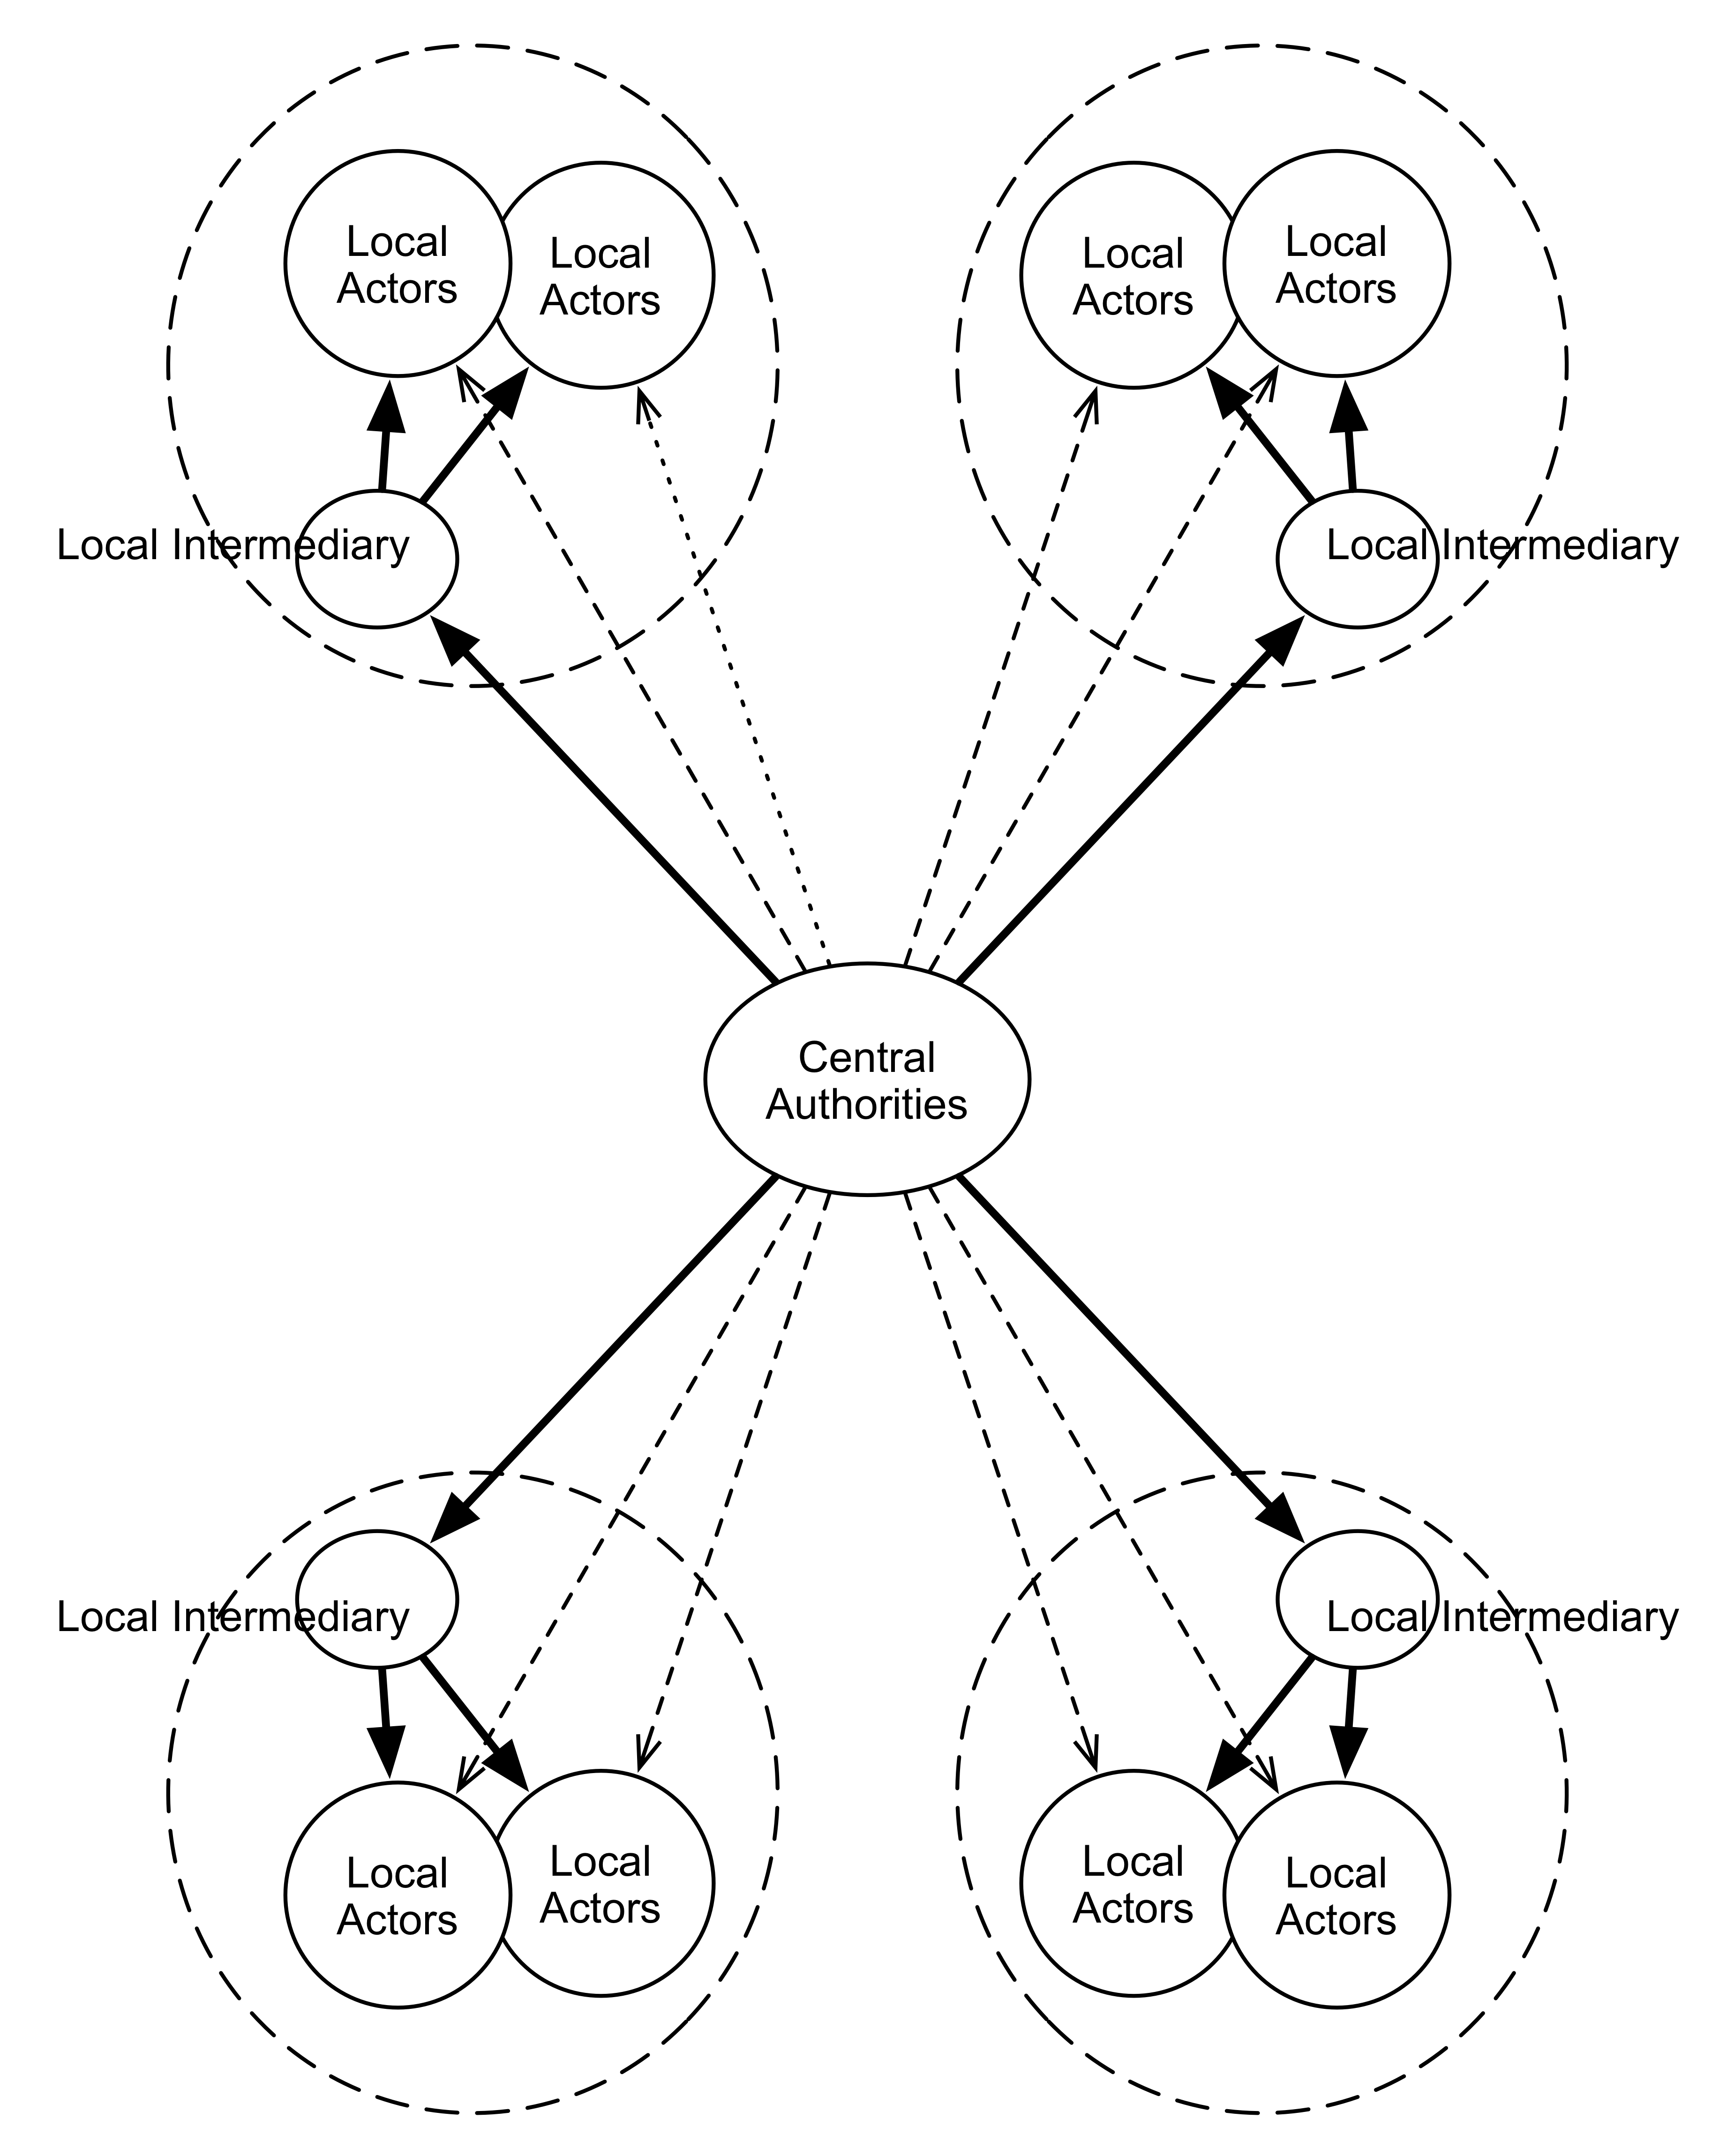
Figure 1: Empire with Four Peripheries

Imperial polities resemble federations insofar as constituent units retain—or are created with—different institutional personalities. The core is not merely distinctive from the periphery, but peripheries are distinctive from one another in terms of (variously) language, cultural identity, and political organization. In federations, however, the basic contract that binds units together—that specifies their rights and obligations—is the same. The fifty U.S. states, for example, are all subject to the U.S. Constitution . In empires, the distinctiveness of individual units is further enhanced by the existence of different terms of incorporation for each of them. Consider the difference between Rome and different provinces in the early empire, how Ottoman rulers treated with different ethnic groups, or the broad range of relations that characterized London’s authoritative interactions with Ireland, Indian principalities, Hong Kong, Egypt, and Rhodesia during the late nineteenth century .
Conceptualizing empire as a political-organizational form not only helps clarify the relationship between liberal order and empire, but also highlights a number of common mistakes made in discussions of empire and contemporary order. Many scholarly and popular definitions of empire associate the term with great-power status or with overwhelming power. Lieven argues that “an empire has to be a great power.” Some go even further and render “great power” and “empire” conceptually equivalent. For example, Lefever defines “an imperial power” as “an established state having the military, technical, and economic capacity to influence, often profoundly, the daily lives and culture of peoples beyond its territory.” It is true, of course, that most great powers have controlled empires—for most of human history empire has been the most successful and enduring means of acquiring significant military and economic might. But the two concepts are logically independent. Twenty-first century Japan, Germany, and France are all great powers, but they are not, in the main, imperial ones. Nor are all empires great powers. No sane person would consider prewar Belgium a great power, yet, as the Congolese can attest, it was most certainly an imperial one.
Making this distinction highlights that conflating relative international power with imperial status biases the debate in favor of those who want to identify the United States as an empire. It is undeniable that the United States is a global hegemon—albeit a declining one—and the world’s sole military superpower. Even as its relative decline continues, Washington will remain one of only a handful of great powers, and likely primus inter pares among that select group. Some advocates of the existence of an “American Empire,” of course, argue that “hegemony” is merely a euphemism for informal empire . But they are wrong. Hegemonic powers do not exercise rule over the domestic affairs of weaker states. Nor do hegemonic orders blur the distinction between international and domestic politics that typically characterizes relations among sovereign states. Imperial relations operate differently than those found in unipolar anarchy or hegemonic orders precisely because of the importance of imperial penetration into the domestic sphere .
The definition we employ differs from that presented by Spruyt in this volume in our strict emphasis on structure. Like Spruyt’s definition, the structural view of empire is one that applies to empires across time and space; moreover, we share his goal of elaborating an ideal-typical conception of the phenomenon. We also converge on a shared understanding of empire as inescapably hierarchical, asymmetric, and heterogeneous. Our differences are thus outnumbered by our similarities. But whereas Spruyt focuses on formal empire, we believe that contemporary manifestations of imperial phenomena are almost certain to be “informal.” Given the opprobrium that attaches to the term “empire” in contemporary international discourse, even a perfectly imperial polity would likely decline the title. Finally, and most important, we do not consider the “mode of legitimation” of empire in this typology. This is an important topic, but it is not one that contributes much to the understanding of the subjects we investigate in this chapter. Indeed, the grammar of such legitimation claims (if not the specific content) seems to vary little across empires. Our wager is that a structural account of empire yields a parsimonious and powerful account of the conduct, expansion, and weaknesses associated with imperial strategies, which is our concern.

Ideal Types and Structural Similarities
In our view, concepts such as “unipolar anarchy,” “hegemony,” and “empire” are best conceptualized as ideal types. Actual political relationships and organizations invariably depart from idealized definitions; they often combine elements of different types. For example, the United States did form imperial relationships with Iraq and Afghanistan during the first decade of the twenty-first century by virtue of occupying them, ruling them through a variety of different intermediaries, and developing different asymmetric bargains with them. But those imperial relationships did not mean that the totality of U.S. foreign relations had an imperial character. Washington’s relations with the United Kingdom, France, Russia, and China contained little or no imperial characteristics. Furthermore, U.S. relations with Iraq and Afghanistan deviated in important ways from ideal-typical empires. In particular, the U.S. did not monopolize the external relations of either Iraq or Afghanistan. By the same token, aspects of U.S.-Japanese and U.S.-Korean security relations have had an imperial cast. For instance, in wartime South Korean troops will fight under American command (an arrangement set to expire in 2015)—a classic example of imperial rule.
How do we identify relationships as being imperial in character? We look for structural similarities between them and our ideal-typical description of imperial systems. But this isn’t simply a matter of definition. Rather, it’s because similarly structured relationships operate according to similar mechanisms and processes. Indeed, we agree with those who argue that similarities in the formal properties of relationships will lead to similar dynamics even if the content—the meanings associated with those relationships—are distinctive. It follows that a variety of different motivations can produce—whether intentionally or unintentionally—imperial modes of organization, and that the status of any set of relations as imperial is independent of what people call them. The fact that U.S. officials rejected the label “empire” to describe the occupation of Iraq—and that international legal opinion agrees that occupation is not the same of as empire—does not change the fact that, for close to ten years, U.S.-Iraqi relations took on an imperial form. Nor should it distract us from how imperial dynamics operated in that relationship.
In sum, an adequate account of liberalism and the “imperial temptation” derives from understanding “empire” as an organizational form, recognizing that imperial relationships may form for a variety of reasons, and identifying those relationships by comparing them to a baseline derived from historical empires. Other approaches, particularly those that equate empire with “powerful states” or refuse to recognize a distinction between empire and hegemony, confuse the issue by rendering all post-1945 U.S. foreign relations “imperial” by definitional fiat.

Neoconservativism and Internationalism as Flavors of Liberalism

As we noted at the outset, one of the most interesting aspects of the “American Empire” debate was the way it cut across ideological boundaries. Many supporters of the Bush Administration not only embraced the characterization of the United States as an empire but also described it as the heir of the British Empire. They argued that, like Britain before it, the United States must use its imperial might to promote international liberalism and democracy. Mainstream critics of Bush foreign policy, in contrast, accused it of abandoning international liberalism. The specific policy dimensions of this debate also cut across ideological lines. A number of prominent liberals endorsed the culmination of the Bush Doctrine: the U.S.-led invasion of Iraq, while a number of traditional conservative establishment foreign-policy figures opposed it.
Indeed, the rise of neoconservative foreign-policy principles in their post-Cold War variant scrambled the conventional realist-liberal divide embraced by both pundits and international relations theorists. Neoconservative foreign-policy principles adopt elements of liberal internationalism, such as the importance of liberal values like freedom, democracy, and open markets, to foreign policy decision-making. While many realists decry the tendency of the United States to engage in ideological crusades, neoconservatives, like liberals, argue that Washington should use its influence to enlarge the community of democratic nations. Unlike liberal internationalists, they express intense skepticism about the power of international law, norms, and institutions to restrain power-political competition.
The neoconservative call for the United States to embrace power-maximization strategies, its dismissal of international institutions, and its penchant for unilateralism each reflect realist criticisms of liberal internationalism. These positions, however, do not place them outside the liberal fold. For some neoconservatives, the problem with existing international institutions lies in their illiberalism—specifically, the influence they grant to non-democratic and illiberal regimes. The United States therefore must embrace unilateralism out of necessity: not only does the influence of illiberal regimes hamper effective multilateral responses in institutions such as the United Nations, but democratic allies—whether from corrupt economic entanglements, a lack of commitment to liberal principles, or willful ignorance—sometimes fail to recognize the threat posed by the enemies of liberal order. Even when U.S. allies acknowledge the dangers posed by terrorists, rogue states, and authoritarian great powers, they often lack an appreciation for the key role of military force in protecting civilization from such anti-democratic threats .
For others, faith in international institutions is almost always misplaced; rather, the United States should combine military power with democratic purpose. Joshua Muravchik , a prominent neoconservative foreign-policy pundit, argues:

The military historian Max Boot has aptly labeled [neoconservativism] “hard Wilsonianism.” It does not mesh neatly with the familiar dichotomy between “realists” and “idealists.” It is indeed idealistic in its internationalism and its faith in democracy and freedom, but it is hardheaded, not to say jaundiced, in its image of our adversaries and its assessment of international organizations. Nor is its idealism to be confused with the idealism of the “peace” camp. Over the course of the past century, various schemes for keeping the peace—the League of Nations, the UN, the treaty to outlaw war, arms-control regimes—have all proved fatuous. In the meantime, what has in fact kept the peace (whenever it has been kept) is something quite different: strength, alliances, and deterrence. Also in the meantime, “idealistic” schemes for promoting not peace but freedom—self-determination for European peoples after World War I, decolonization after World War II, the democratization of Germany, Japan, Italy, and Austria, the global advocacy of human rights—have brought substantial and beneficial results.

As Schmidt and Williams argue, by “embracing democracy as the universally best form of government, and by committing themselves to spreading democracy across the globe, neoconservatives are in important respects the heirs of Wilsonian liberalism.”
All of this helps make sense of one dimension of the relationship between empire and liberal order. In his essay “Perpetual Peace: A Philosophical Sketch,” Immanuel Kant argued that the elimination of warfare requires a world composed of republican regimes, linked by trade, and joined together in a federation of states. For Kant, each of these conditions reinforced one another, leading to an equilibrium in all three conjoined to eliminate warfare. But contemporary international liberals disagree—both in terms of policy and theory—over the relative importance of each .
For our present purposes, we should distinguish between two extreme positions on the proper character of “liberal order”: one that exclusively focuses on the liberal character of the states that populate the international system, and another that overwhelmingly privileges the existence of a liberal order among states. We might term the first liberal enlargement and the second intergovernmental liberalism. The former concerns itself most with state-society liberal practices, while the latter with inter-state liberal practices. Whatever Kantians might think about the direction of historical processes, in practice these two extremes generate tensions with one another. For example, a commitment to intergovernmental liberalism—in the form of such principles as the recognition of sovereign equality, mutual self-restraint, and multilateral decision-making—effectively shields autocratic regimes against international pressure to liberalize their policies and institutions. A robust commitment to liberal enlargement, on the other hand, implies a relaxation of state sovereignty.
The tradeoff for liberals, then, is between the degree of hierarchy in inter-state relations that they are willing to tolerate in the advancement of their values. The typology of empire we present depends on establishment of strictly hierarchical relationships between core and periphery. Yet we could imagine a powerful United States that, in the (mostly rhetorical) tradition of the “city on a hill,” promoted liberal enlargement via exemplarism, without establishing authoritative control over targeted illiberal states. Such an American policy would not be tantamount to empire. Taking empire seriously should also inoculate us to the belief that multilateralism is a cure for empire. Because the typology is indifferent with respect to the composition of the actors that fill its structure, there is no reason why the core could not be a grouping of several liberal states that pursued liberal enlargement by pursuing a strategy of establishing imperial relations with target states.
Our explanation of how liberal dynamics intersect with imperial structures thus makes Ikenberry’s “imperial temptation” more than poetic. Instead, the temptation arises from the fact that contemporary liberal states are powerful enough to eschew exemplarism and pursue enlargement via more direct, imperial means. In the United States, much of the debate between neoconservatives and liberal internationalists hinges on the relative importance of transnational and intergovernmental liberalism. Neoconservatives privilege transnational liberalism over intergovernmental liberalism. Liberal internationalists, in contrast, tilt in favor of the latter.

Hierarchy, Liberalism, and Empire
Liberal intergovernmentalism and liberal enlargement become most relevant to the question of “American Empire” in terms of how they interact with international hierarchy. The relationship between liberal order and empire is illustrated in Figure 2. The vertical axis represents different degrees of commitment to liberal intergovernmentalism and liberal enlargement; the middle point constitutes a balance between them. The horizontal axis represents growing hierarchy, understood as an increasing concentration of relative power among fewer and fewer political communities.
The contemporary international order contains significant elements of hierarchy . For example, the United States took the lead role in creating a liberal order after the Second World War, and it has used its superior military and economic influence to sustain it for the intervening six-and-a-half decades . The overall character of the international system matters to the relationship between liberalism and empire; as we delineate below, a dominant power that evinces a strong preference for liberal enlargement will tend to form imperial relationships with other states.

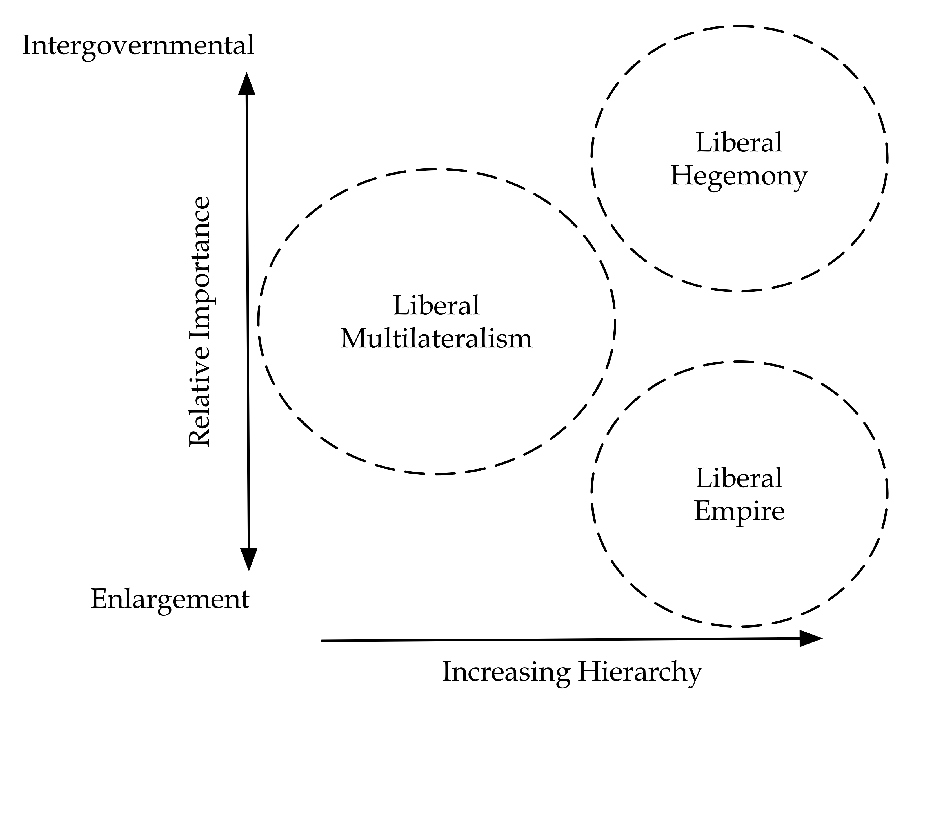
Figure 2: Liberal Empire and Liberal Hegemony

But what matters more than the degree of hierarchy in the international system is the degree to which authority matters in the relations among specific states. Our claims are straightforward:

- Genuine multilateralism tends to predominate when relations among relevant states are relatively equal and those relations are governed by a range of balances between enlargement and intergovernmentalism;
- As power relations become more hierarchical but liberal intergovernmentalism predominates, we will tend to see the formation of liberal hegemonic orders, i.e., multilateral institutions and regimes undergirded and inflected by the leadership of dominant powers; and
- As power relations become more hierarchical but liberal enlargement predominates, we will tend to see the formation of liberal empires, i.e., dominant states enforcing and maintaining elements of liberal order within the domestic spheres of other political communities via indirect rule and heterogeneous contracting.

Treating intergovernmentalism and enlargement as two competing—and often contradictory—impulses in liberalism clarifies the liberal “imperial temptation” better than a number of existing accounts. Desch , for example, argues that liberalism over-determined Washington’s embrace of imperial policies after September 11, 2001. Caverley claims, in contrast, that neoconservativism is illiberal because it rejects the pacifying effects of trade and institutions. Both neglect that liberalism cashes out in a variety of different ways when it comes to foreign (and, for that matter, domestic) policy.
Indeed, one not need adopt a particularly close reading of different forms of liberal ideology to understand why powerful states that embark on aggressive liberal enlargement tend to form imperial relationships with other polities. Through occupation, the use of coercive diplomacy, and other means, such states create patterns of formal and informal indirect rule and heterogeneous bargaining. They do so in order to consolidate, maintain, and expand the liberal writ, thereby maximizing the geopolitical space in which markets, individual rights, and/or democracy predominate. When states adopt a more intergovernmental form of liberalism, they may also seek liberal enlargement but they restrict their ability to utilize informal interstate empire as means to that end. Hence the neoconservative frustration with the ways in which the United Nations, as well as a number of other international institutions, empower autocratic states and provide them with a mechanism to constrain Washington’s ability to promote liberal democratic principles.
We should keep in mind, however, that the practice of post-war U.S. foreign policy has usually involved attempts to balance these competing impulses—not simply with one another but also with power-political imperatives. Thus, most administrations have pursued some mix of liberal enlargement and liberal intergovernmentalism. Even the Bush administration, much derided for its unilateralism and antipathy toward international institutions, worked through international institutions in a variety of different policy arenas.
By the same token, both so-called neoconservatives and liberal internationalists have advocated—and even played an important role in bringing into being—policies that favor the formation of imperial relations. The U.S.-led occupation of Iraq rendered the latter a temporary imperial province: Washington ruled Iraq via local intermediaries—first westerners in the Coalition Provisional Authority (CPA) and then Iraqis in the provisional government—based on evolving bargains that differed from those involved in U.S. relations with other client states. But liberal internationalists, not neoconservatives, imposed agreements on Germany and Japan after World War II that gave the U.S. significant control over their security policy . The issue isn’t so much one of “neoconservativism” versus “liberal internationalism,” but of how specific actors balance the competing pulls of liberal enlargement and intergovernmentalism. As Jon Monten notes, the champions of U.S. formal empire after the Spanish-American War could hardly be described as “neoconservatives”: indeed, much of the impetus for Washington’s colonial experiments in the Philippines and other former Spanish territories was rooted in progressive ideology.

International Liberalism and the Displacement of Imperial Functions

Liberal internationalists often argue that their focus on intergovernmentalism need not come at the expense of a growing sphere of domestic liberal governance. Although autocratic regimes have, for example, subverted the United Nations Human Rights Council, liberal internationalists argue that there is no way that the United States (or any other great power) could compel many of those states to respect human rights. Indeed, the U.S. itself frequently supports illiberal regimes when doing so advances its power-political interests. At the same time, they contend that liberal international order ultimately spreads domestic liberalism by:

- Encouraging and enforcing compliance with liberal norms and practices, such as respect for human rights, peaceful resolution of disputes, and open trade;
- Empowering individuals and groups to push for political liberalization within autocratic states;
- Facilitating pro-democratic and pro-liberal actions by sovereign states, such as humanitarian interventions; and
- Engaging in nation-building, security-sector reform, and peacekeeping activities.

These positive effects, liberal internationalists argue, outweigh the negative ones that stem from autocratic and illiberal states using their voice opportunities and votes to stymie institutional action. In the long run, they claim, multilateralism will advance both liberal international order and liberal domestic order.

Regardless of the truth of the neo-Wilsonian argument, it does call attention to an important aspect of the evolving post-1945 liberal order, which now includes the United Nations, the International Monetary Fund (IMF), the World Bank, the General Agreement on Tariffs and Trade (GATT) process, the World Trade Organization (WTO), and NATO). In many ways, the postwar order constitutes an attempt to preserve the benefits of (liberal) imperial order without its costs. Empires often promote public order and facilitate trade; they deal with what we now call “failed states”; and they spread technology, knowledge, and ideas.

Contemporary liberal internationalism values all of these public and private international goods, but it sees empires as inherently illegitimate due to their reliance on coercion, their denial of self-determination to imperialized peoples, as well as the killing, pillaging, starvation, and destruction that tends to accompany their rise and rule. The solution they offer, in effect is to “democratize” imperial functions by handing them over to institutions that can claim—even if often in a rather strained sense—to represent the “international community.”

Such displacement of imperial activities involves more than simply “functions”: it leads to the formation of empire-like arrangements. Recall our earlier claim that imperial relationships do not depend on the specific meanings associated with them or the specific actors implicated in them. Businesses may be organized along imperial lines, with a central authority exercising authority indirectly over segmented departments via differential bargains—such as in some multinational corporations or particularly unpleasant office environments. We can speak of an informal U.S. empire to the extent that Washington forms imperial relationships with other, nominally sovereign and independent states. Similarly, there is nothing to prevent an imperial relationship from existing in which an international organization, multilateral alliance, or collection of actors occupies the position of the core/central authorities. The telltale signs would, as before, be the establishment of inter-actor hierarchy and heterogeneous contracting.
For example, peacekeeping and stability operations often are composed of multiple counties, international institutions, and even non-governmental organizations. After the 1995 Dayton Accords Bosnia and Herzegovina became, in effect, a trustee of a body known as the Peace Implementation Council (PIC), the majority of whose representatives are drawn from NATO member states and which operates under the authority of the UN. The PIC appoints the High Representative for Bosnia and Herzegovina, who in turn has significant authority over Bosnia’s central and regional governments, including the right to dismiss public officials and implement binding decisions. Although it has been roughly sixteen years since the Dayton Accords, most observers believe that Bosnia would collapse in the absence of foreign troops and oversight.
Conditional aid offered by the IMF and other organs of liberal global governance sometimes also positions them as central authorities in imperial relationships. The crisis in Greece and other peripheral European states (including, as of this writing, Ireland, Spain, and Portugal) demonstrates how international institutions as such can find themselves playing the role of imperial cores deeply interested in the governance of states. Although Athens and other capitals forced to accept international assistance from the European Union and the IMF have tried to resist those bodies’ calls for the remaking of their government and their economy, there is nonetheless a point at which fiscal urgency begets political concessions. The colonial nature of these interventions was clear to the Irish Times in November 2010, as “the Germans” (as they were called) took suzerainty over the Irish economy:

It may seem strange to some that The Irish Times would ask whether this is what the men of 1916 died for: a bailout from the German chancellor with a few shillings of sympathy from the British chancellor on the side. There is the shame of it all. Having obtained our political independence from Britain to be the masters of our own affairs, we have now surrendered our sovereignty to the European Commission, the European Central Bank, and the International Monetary Fund. … The Irish people do not need to be told that, especially for small nations, there is no such thing as absolute sovereignty. We know very well that we have made our independence more meaningful by sharing it with our European neighbours. We are not naive enough to think that this State ever can, or ever could, take large decisions in isolation from the rest of the world. What we do expect, however, is that those decisions will still be our own. A nation’s independence is defined by the choices it can make for itself.
In the Greek and Irish cases, as with many states on the receiving end of conditional assistance before them, the hierarchical and asymmetric nature of the contractual relationship between the core and the periphery is perhaps more evident to those in Athens and Dublin—or Jakarta and Bangkok—than to those in Washington or Brussels. Efforts to bring dependent regimes into compliance with liberal norms have been written into World Bank policy as well.
We therefore need to be careful about the relationship between liberal intergovernmentalism, liberal enlargement, and empire. Liberal-intergovernmentalist tendencies do, as its advocates claim, restrain imperial impulses within liberal polities insofar as they reduce the likelihood of, for instance, Washington forming an imperial relationship with another state. But they also transfer imperial functions onto multilateral organizations and international institutions. In consequence, liberal intergovernmentalism itself promotes the formation of imperial relationships.

Conclusions

Liberalism produces an imperial temptation: it holds that the spread of liberal democracy renders the world more peaceful, more cooperative, and better able to improve human welfare. These beliefs imply that, in one way or another, liberal governments ought to promote their values and generally expand the sum total of global political freedom. In the United States, this viewpoint has led to a variety of strategies. Some have held that Washington best serves the cause by standing aloof from foreign entanglements and providing and example to the rest of the world. Others have advocated more active measures in support of liberalism, including the assumption of formal empire.
But these beliefs also suggest two different layers of liberal governance, one operating in the domestic sphere and one regulating relations between states. These two threads stand in tension with one another insofar as liberal intergovernmentalism restricts the ability of the liberal states to compel others to respect human rights, hold free elections, and otherwise liberalize their domestic spheres. This tension helps explain why liberal internationalists (who privilege intergovernmentalism) accuse neoconservatives (who privilege liberal enlargement) of being imperialists. But unilateralism does not, in of itself, render a liberal state and imperial power. Rather, the pursuit of liberal enlargement generates imperial relationships in which Washington acts as a central authority ruling over other states via local intermediaries.
As we have argued, however, intergovernmentalism generates its own set of imperial relationships—even if the position of “central authority” is occupied by a variety of international institutions and agents of sovereign states. It should comes as little surprise that these relationships usually involve the imposition of liberal policies and principles—whether economic or political—on nominally sovereign states.
Indeed, what we might call the “empire problematique” stands at the center of questions of global order. International relations theorists have tended to see the primary problem of world politics as how to achieve order in the face of anarchy, i.e., the absence of a central authority to make and enforce rules. But it might be more accurate to say that the primary problem of world politics is how to achieve order if we reject the legitimacy of empire. The liberal internationalist solution is not so much to abandon imperial logics, but to attempt to displace them onto putatively legitimate agents, such as the UN and the IMF.
In that sense, Daalder and Lindsay were right: the debate between liberal internationalists and neoconservatives isn’t whether empire, but in what form. But that, in turn, implies that there is little uniquely “American” about the “American Empire” debate. It is instead merely the latest manifestation of a fundamental tension of liberalism. The shift of economic and political power to emerging states may resolve this question, at least in the medium term, by simply removing the neoconservative option. No major rising country—certainly not China—appears set to legitimate regime change, as in Afghanistan or Iraq, with as comparatively little resistance as Washington has faced since the end of the Cold War. (Similarly, we might well wonder whether even the American foreign-policy establishment will be eager to repeat the experience of establishing imperial relationships with newly-conquered provinces.) The real test, however, will be whether such countries will sustain the Bretton Woods and other institutions that Western powers have used to promote liberal ideas through quasi-imperial means.

Prior to his ascendency, Ferguson was perhaps best known outside of Britain for arguing that Germany engaged in World War I for defensive reasons, and that the UK should have allowed a German victory. Doing so, according to Ferguson, would have enable London to retain its global empire and led to a peaceful European order. For an evisceration of Ferguson, see Michael Lind Lind 2011.
Quoted in Schmitt and Landler 2004.
This account of empire has its limits and exceptions. We tend not to describe Canada as an empire, but its constitution treats the francophone province of Quebec differently than its Anglophone provinces. One reason is that rule does not simply flow from the center, but flows to the center from localities via principles of elective representation. But another is that the definition of empire we offer is ideal-typical in character; it provides a stylized definition of empire against which to judge real political entities. We will return to this point in short order.
It is no accident that various counterinsurgency (COIN) principles used in Iraq derived from the lessons of wars of imperial pacification in Africa, Southeast Asia, and elsewhere.
We put aside the contentious issue of how much Britain actually exported democratic governance.
The figure may be somewhat confusing, insofar as we associate liberal hegemony with the creation and maintenance of multilateral institutions, e.g., NATO, the International Monetary Fund (IMF), World Bank, and so forth. In this case, “liberal multilateralism” refers simply to a multilateral order comprised of roughly equal liberal-democratic states.
On these features of U.S. hegemony, see Ruggie 1982; Deudney and Ikenberry 1999; Ikenberry 2001; Ikenberry 2011.
The U.S. also renegotiated the terms of these agreements over time so as to make them significantly less imperial in character. See also Sandars 2000.
Those seeking to rehabilitate the image of empires often stress these benefits while downplaying their cost. They tend to laud the British Empire in particular, whose former colonies do tend to be disproportionately democratic and whose mantle the U.S. arguably took up. See, e.g., Ferguson 2004; Lal 2004.
Office of the High Representative and EU Special Representative, “General Information.” Accessed 4 June 2011. URL: http://www.ohr.int/ohr-info/gen-info/
As of 4 January 2001, 1600 European troops remained in Bosnia. The U.S. and NATO engage in significant defense-institution building activities in the country designed not only to enhance the effectiveness of its military but also its interoperability with NATO forces. See U.S. Department of State, “Background Note: Bosnia and Herzegovina.” Accessed 6 June 2011. URL: http://www.state.gov/r/pa/ei/bgn/2868.htm
For good overviews, see Stephanson 1995; Jackson and Nexon 2003; Jackson 2006.

